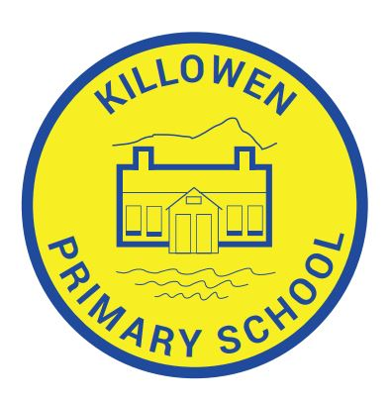
Killowen Primary School Acting Principal
88 Killowen Old Road Mrs. Órla Murphy
Rostrevor
Co. Down Tel (028) 41738426
BT34 3AE
Faith, Friendship & Understanding
info@killowen.rostrevor.ni.sch.uk

Dear Parents & Guardians,
Firstly may I wish you a Happy & Hopeful New Year.
It is not the start we were wishing for, but as the old saying goes – “It’s not how you start, but how you finish that counts”
Secondly, I apologise for the long read that follows, but due to current circumstances it is all necessary.

By now you are at the end of your 2nd week of home – schooling in Lockdown, which really in actual fact is closer to crisis management than parentcraft. So I want you to know that we as a school are here for you every step of the way. You do not have to navigate your child’s continued education alone. Please don’t hesitate to email me or your child’s teacher for help, support, resources, advice, information or simply to talk over any concerns you may have about your child. The phone line is also manned from 9am to 4pm daily, except Tuesday, when I am on duty with the children of Key Workers.

Let me assure you that everyone is worried about their child’s education, and no-one is feeling in control of this situation. However, we are all managing our own individual circumstances with whatever coping strategies that are necessary to survive – and that is enough. Many changes and amendments have already been made to the education system in the last 10 months, and there will have to be many more. Curriculums will have to be streamlined, testing will have to be adjusted, standards and benchmarks will have to be reviewed. Therefore, you will find at the end of this, your child is exactly where they are expected to be – and if for any reason they are not, new measures will already be in place to rectify those issues for them.

The original workpacks for P1 – P5 provided on Tues 5th Jan, when schools expected to open the following week, were contingency booklets estimated to cover 2 – 3 weeks just in case the Lockdown was extended. Now that remote learning has been extended until the mid-term break, a 2nd work pack is ready for collection on the following days;
P2/3 – Tuesday 19th January between 10am – 2pm contact omurphy479@c2kni.net
P4/5 – Thursday 21st January between 10am – 2pm contact mcruz105@c2kni.net
P1only – Friday 22nd January between 10am – 2pm contact levans768@c2kni.net

Please contact your child’s teacher if you cannot pick-up on schedule and she will arrange to post out the work or deliver it, depending on numbers.

Mrs. Cunningham had already added extra booklets and activities in her class packs considering the demands made on senior pupils, and therefore will not supply any new material until the beginning of February unless by request. Contact acunningham628@c2kni.net
Likewise, Lorna filled the Reception packs with an abundance of activities and they will not need replenishing before half term.

The teachers are posting messages and activities daily on Seesaw. Next week they will post a personal video message to the children. Even if you do not want to engage with the activities, I would encourage you to log in to let the children see and hear their teacher. It provides a security blanket for them, it brings a touch of normality and what educators learned most from last year, was that the teacher presence in remote learning was highly effective in keeping children motivated and positive as well as preventing school related stress and school refusal when Lockdown lifted. If you need a Seesaw Userguide or your child’s home code, please contact the class teacher.

Other successful outcomes from the previous Lockdown hinged on
- Establishing a daily routine or structure
- Setting time-bound tasks with scheduled breaks & rewards
- Not over crowding the day with a full timetable
- Choosing 2 or 3 learning platforms only and revisiting them regularly
- Keeping expectations reasonable and
- Reading, Reading, Reading

Indeed, should you do nothing else but read TO your child, read WITH your child and let your child READ to you, then you will have completed the single most important task of all. Órla Murphy

C2K My School Apps www.myschool.com
You can access all the apps such as Newsdesk and C2k Media at home just ask your child’s teacher for their C2k Username and Password

Accelerated Reader https://ukhosted102.renlearn.co.uk/2235268
Any pupil who was previously using Acellerated Reader may now continue to read and quiz at home as the licences have been renewed. If they need reminding of the AR Username and Password, please email Mrs Murphy. A license has also been purchased for every pupil from P3 – P7 and as soon as their registration comes through, they will be issued with log in details and a user guide.

Wordshark https://onwordshark.com/killowenpsrostrevor/login
Pupils who were introduced to Wordshark may continue to do so. If they need reminding of log in details, please contact Mrs. Murphy. We are in the process of adding more classes to this literacy platform and will issue log ins and guides in due course.

Oxford Owl www.oxfordowl.co.uk
Please find enclosed log in details for all pupils to access free levelled e-books at home. Even though you are at home, choose OXFORD OWL FOR SCHOOL. Select books by age or level.

The Literacy Shed www.literacyshed.com
is a great resource for short films with short comprehension exercises or quizzes or activities. Check out the Fun Shed which is free.

Epic! getepic.com
A vast digital library with interactive books, audio books, read-to-me books, videos, games and more. Earn points and prizes as you read. See attached log in details.

10Ticks 10ticks.com
Sharpen up your Mental Maths skills in the 4 rules of addition, subtraction, multiplication and division.Compete with other children around the world. Ask the class teacher for access.

Top Marks www.topmarks.co.uk
Lots of maths games graded by age and topic. Try the Hit The Button activities

Cool Maths Games coolmathsgames.com
Games of strategy, skill and logic made to look like modern video games. Very popular with KS2 pupils.

Ultimate list of free educational resources for parents –
www.irishexaminer.com/lifestyle/wellbeing/arid-40202144.html

WEEKLY EVENTS.
BBC Bitesize has a full timetable every week during Lockdown

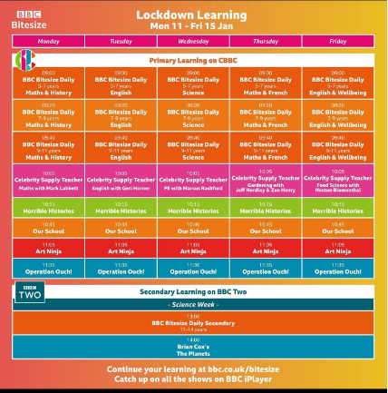

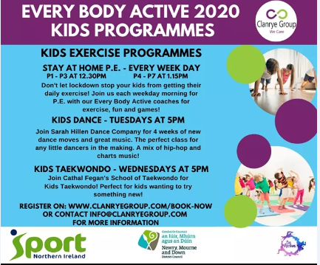

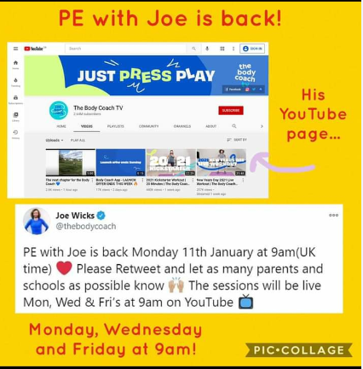

USEFUL INFORMATION
