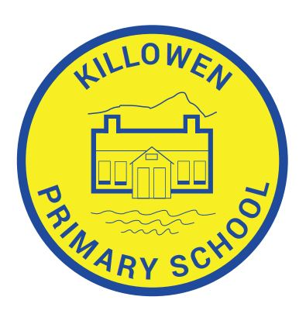
Killowen Primary School Acting Principal
88 Killowen Old Road Mrs. Órla Murphy
Rostrevor
Co. Down Tel (028) 41738426
BT34 3AE
Faith, Friendship & Understanding
info@killowen.rostrevor.ni.sch.uk

27th February 2024

Dear Parent,

We have been asked by the School Nursing Team to share the information below with you:-

For children and young people who are outstanding their MMR vaccine, clinics will run on
Saturday 9th March | 2pm - 4pm | The Quays, Newry | Bookings / Walk-ins welcome
Wednesday 13th March | 2pm - 4pm | Portadown Health Centre (provisionally) | Bookings only
Thursday 21st March | 2pm - 4pm | St Luke's Hospital Vaccination Centre, Armagh | Bookings / Walk-ins welcome
Saturday 23rd March | 2pm - 4pm | Lurgan Children's Centre, Lurgan Hospital | Bookings / Walk-ins welcome
Sunday 24th March | 2pm - 4pm | The Junction, Dungannon | Bookings / Walk-ins welcome
Thursday 28th March | 2pm - 4pm | Portadown Health Centre (provisionally) | Bookings only

An additional clinic has been added for Friday 22nd March 530-830pm for bookings and walk ins – Clanrye House Daisy Hill Hospital

This is for children aged between 6-16 years old who have not received two doses of the MMR vaccine. Walk ins are welcome in some of the areas (listed above). Appointments can be booked via this hyperlink Mumps, Measles and Rubella (MMR) vaccine | Southern Health & Social Care Trust (hscni.net)

Kind Regards,

Mr Murtagh
Principal (Acting)

