KILLOWEN P.S.

ROSTREVOR

GOVERNORS’ REPORT

SCHOOL YEAR
2014--2015

KILLOWEN PRIMARY SCHOOL

BOARD OF GOVERNORS

VOTING MEMBERS 2014-2018
Fr. Brendan Kearns | Chairperson | Trustee Representative
Mrs. Grainne Forsythe | Vice-Chairperson | EA Southern Representative
Mrs. Catherine McDonagh |  | DENI Representative
Mrs. Catherine McKeveney |  | Trustee Representative
Mrs. Caitriona O’Farrell |  | Trustee Representative
Mrs. Deirdre Cahill-Leonard |  | Trustee Representative
Mrs. Anne Clarke |  | Teacher Representative  ( elected )
Mrs. Margaret Hudson | Designated Governor for Child Protection | Parent Representative (elected )
Mr. Mick Murphy |  | EA Southern Representative

NON-VOTING MEMBERS
Mr. Diarmuid Maginn | Principal

For parents wishing to become a governor, nominations and an election will take place towards the end of 2018 or early in 2019, depending on the timetable for reconstitution of boards of governors.

STAFFING COMPLEMENT

Class | Teacher
Reception/P1/2 | Mrs. L. Evans  ( Classroom Assistant Mrs. M. McCourt)
P3 | Miss M. O’Neill
P4/5 | Mrs. A. Cunningham  (Classroom Assistant Miss L. McElroy)
P6 | Mrs. A. Clarke  (Classroom Assistant Mrs. A. McNally)
P7 | Mr. D. Maginn
School Secretary | Mrs. S. Newell
Building Supervisor - Caretaker | Mrs. M. Sloan
Dining Attendants | Mrs. M. Rea  Mrs. K. Morgan

INTRODUCTION
Killowen Primary is a Catholic school. The Governors are committed to the aims of Catholic schools and the values of the Church.

ORGANISATION AND MANAGEMENT
The Board of Governors has overall responsibility for the effective management of the school. As well as nominees of the Trustees, the Southern Education and Library Board and Department of Education, its membership includes an elected parent governor elected by parents and a teacher governor elected by the teaching staff. The Principal is a non-voting member.

The Board of Governors therefore represents all the main interests concerned with the school. The Governors have particular responsibilities in relation to:
- The Curriculum
- The Appointment of Staff
- Admission to the school
- Discipline
- Buildings
- Budget
- School Development Planning

THE CURRICULUM

When we speak of the curriculum in our Catholic school we mean all the opportunities for learning provided by the school. This includes not only the formal lessons but all the experiences offered to our children by our school ethos and environment. All our curriculum will endeavor to reflect Christ’s message. Each child was offered a formal curriculum which was broadly based and balanced with the Northern Ireland Curriculum.

Areas of Study
Religious Education
Language and Literacy
Numeracy and Number
The World Around Us
The Arts (Art and Design/ Drama/ Music)
Physical Education
Personal Development and Mutual Understanding

The day-to-day organization of the curriculum is the responsibility of the Principal and Staff. Services of the SELB Music Advisers were used to extend and develop the music curriculum.

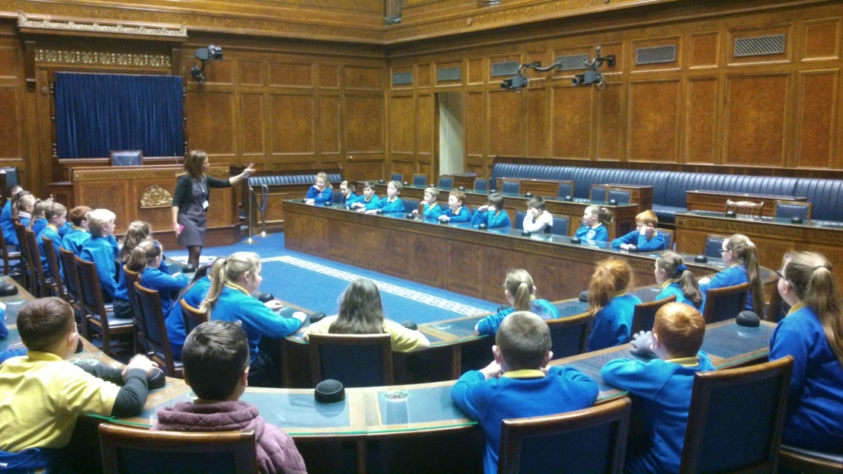

VISIT TO STORMONT DECEMBER 2014

RELIGIOUS EDUCATION

As a Catholic school, we follow the ‘Alive-O’ Religious Programme, which offers the children many opportunities for discussion about not only religious ideas, but also how they live alongside their fellow classmates and neighbours, in line also with the Personal Development and Mutual Understanding Programme. We say daily class prayers, hold weekly assemblies, organise special prayer services in honour of our patron saints St. Brigid and St. Patrick and help parents to prepare the children for the sacraments of First Confession, First Holy Communion and Confirmation.

If any parent does not wish their child to follow this programme, they are entitled to ask for their children to be withdrawn from these classes.

SPECIAL EDUCATIONAL NEEDS

The special needs programme aims to identify children with special needs at the earliest opportunity, from the moment they enter the school, if not before that. With parental approval, the children can then be placed on a register of special needs which places them on a series of stages, whereby the school will offer various levels of support;
Stage One – individual education plan is drawn up
Stage Two – child continues to have an individual education plan
Stage Three – outside agencies are contacted for advice
Stage Four – educational psychologist assesses child
Stage Five – additional support is provided in terms of classroom/domestic assistant, special equipment and/or assistive technology.

Facilities are the same for all pupils – access to all parts of the school are equal, with all classrooms and entrances wheelchair –friendly. A special state-of-the-art disabled toilet is available on site.

ASSESSMENT/REPORTING

The summary results for the school over the past three years are shown above.
Subject | Year Group | 2013 | 2014 | 2015 | Last 3 years’ average | NI Average  (2015)
Communication  ( English ) | Key Stage 1  ( P4 ) Level 2 and above | 17/19 pupils  90% | 9/11  82% | 12/12  100% | 94% | 88.7%
 | Key Stage 2  ( P7 ) Level 2 and above | 10/12  83% | 11/12  92% | 11/19  56% | 77% | 76.8%
Using  Maths | Key Stage 1  ( P4 ) Level 2 and above | 18/19  95% | 9/11  82% | 12/12  100% | 92% | 90.3%
 | Key Stage 2  ( P7 ) Level 2 and above | 11/12  92% | 12/12  100% | 15/19  78% | 90% | 77.4%

Individual parent/teacher meetings were held in November for P1 – P7. A comprehensive written report was devised and issued to parents in June 2015. Primary 4 and Primary 7 pupils take part in the Council for Curriculum Examinations and Assessment Key Stage Statutory assessment procedures however due to industrial action by the teaching unions, no levels were sent to CCEA for P4 / P7 classes during the 2014/15 school year.

As well, a range of assessment tests are used in each year;

YEAR | TESTS
P1 | OBSERVATIONAL TESTING
P2 | MIDDLE INFANT SCREENING TEST
P3-7 | PROGRESS IN ENGLISH/PROGRESS IN MATHEMATICS STANDARDISED TESTS

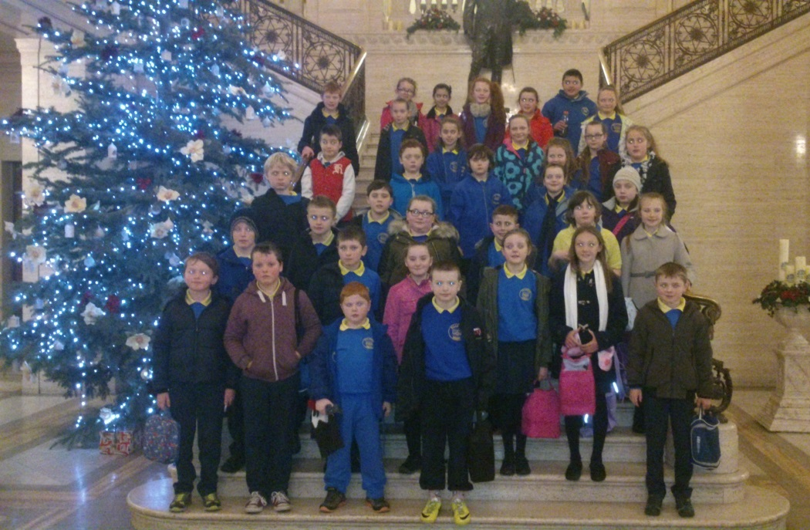

INSIDE PARLIAMENT BUILDINGS - THE GREAT HALL

SCHOOL AND THE COMMUNITY

Liaison teachers from local post-primary schools visited Primary 7 pupils in relation to the transfer to post primary school and teachers from St. Louis’ Grammar School carried out science workshops for P6 and P7 pupils. Our school extended links with the local community. Approximately 30 children from Primary 1 to Primary 7 participated in the verse speaking schools section of Warrenpoint Feis. Many received medals and certificates and it was an enjoyable and valuable experience. The Recorder Ensemble won two trophies, at Warrenpoint and Newry. Our choir also participated in the Féis this year.

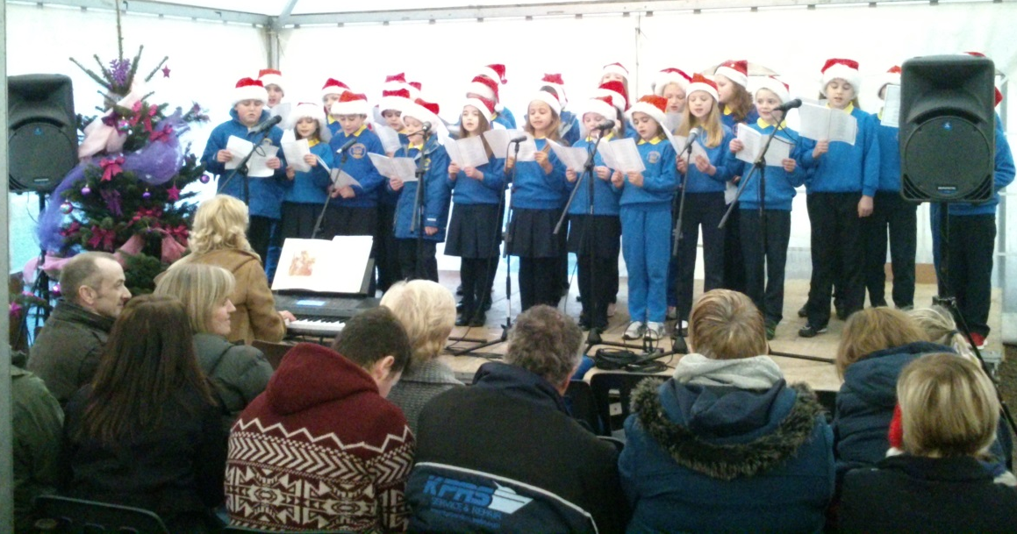

The choir continued to perform on several occasions throughout the school year, helping to raise funds for Muscular Dystrophy and participating in the second Cross-Border Peace Prom. They greatly enhanced the Liturgy at First Penance, First Holy Communion and Confirmation Services and at all our school masses.

All of the children performed beautifully in our Christmas Concert for parents and guests in December, with every single child having either a speaking or singing part.

Children took part in a variety of competitions. The Credit Union Quiz and Poster Competition are firm favourites at the school. Several children won prizes.

Our school Book Fair was held this year, raising somewhere in the region of £600 to be spent on books for the children. The Trócaire collection raised approximately £210.

Our Parents’ Support Group organised several activities which not only raised valuable funds but also brought together our families in a social setting. Our Cake Sale was a huge success and children from Primary 7 were involved in a ‘Junior Entrepreneur Programme’ with Mash Direct and they raised approximately £200 from the sale of their creations.

The Governors would like to thank all those parents who became actively involved in the life of the school as a result of these initiatives.

PHYSICAL EDUCATION

At Killowen, we aim to provide a wide range of sporting experiences for our children. These include Athletics, Gaelic football, Netball, Soccer and Tennis. Our soccer team took part in the Mourne Small Schools’ League. Throughout the school year our children participate in a variety of inter-school and cross community activities.

Swimming was undertaken by children in Key Stage 2 - P5 to P7.

SCHOOL HOLIDAYS

2014/2015

SCHOOL BEGINS | School opens – Monday 1st September 2014 – All pupils
HALLOWEEN BREAK | School closed Wednesday 29th October 2014 to Friday 31st October 2014.  School re-opens on Monday 3rd November 2014
CHRISTMAS HOLIDAYS | School closes Friday 19th December 2014 at 12.00
SPRING TERM | School re-opens Monday 5th January 2015 - All pupils  School closed Friday 30th January 2015 (Exceptional Closure)
MID TERM BREAK | School closed Monday 16th February to Friday 20th February 2015.  School re-opens Monday 23rd February 2014 - All pupils
MARCH CLOSURES | School closes on Monday 16th (Exceptional Closure) and Tuesday 17th March 2015.  School re-opens on Wednesday 18 March 2015 – All pupils
EASTER HOLIDAYS | School closes Thursday 2nd April 2015 at 12.00am
SUMMER TERM | School re-opens Monday 13th April 2015.
MAY CLOSURES | School closed Monday 4th May 2015 and Monday 25th May 2015.
SUMMER HOLIDAYS | School Closes on Friday 26th June 2015 at 12.00.

FINANCE

Management of Finance was undertaken jointly by BOG, CCMS and SELB, DENI provided additional initial expenditure funding.

SELB Summary of Budget Report
(12 months ended 31 March 2014)
School Budget Share: £ 338,915
Total Spent to date: £ 356,135
Provisional Balance - £ 17,220

SCHOOL ACCOUNT

Financial Statement 30 June 2015

Receipts and Payments 1 Sept 2014 – 30 June 2015
These figures are those as per our record of school accounts.

Receipts 07 11 ‘14 £ 3,800.00
Payments £ 3,457.95
Balance June 2015 + £ 342.05 Credit

SECURITY OF PUPILS AND STAFF

The security and safety of pupils and staff is always being considered by the Governors. In June 2014, the Principal filed two minor works applications with the governing body, the Catholic Council for Maintained Schools, to refurbish the toilet block at the rear of the school and to secure the site with perimeter fencing at the front of the school.

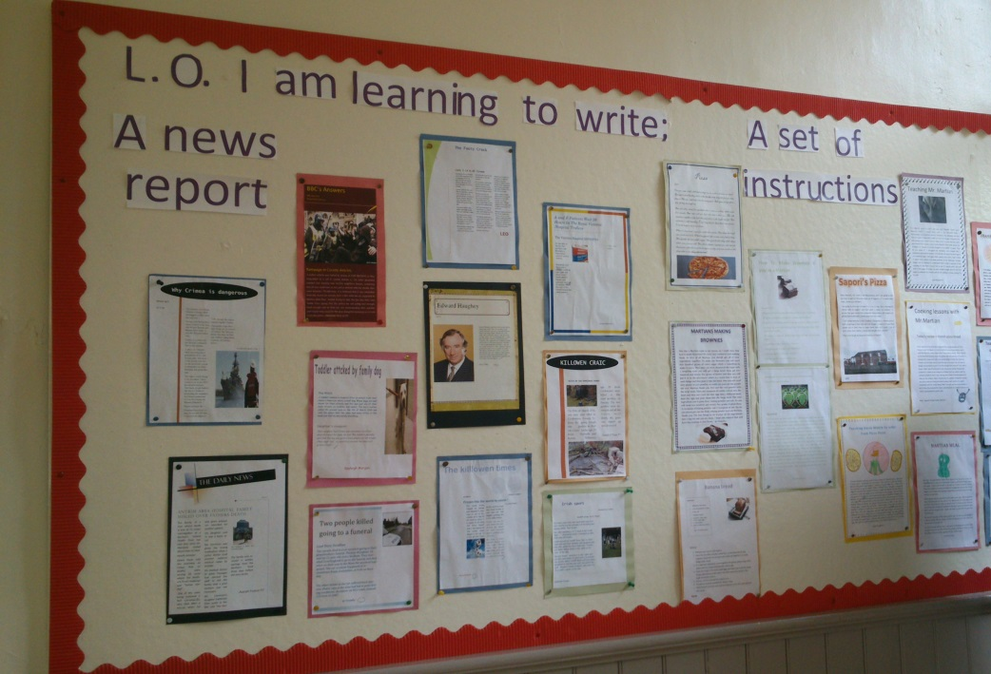

LITERACY NOTICE-BOARD

Access Arrangements
Until such times as the school is granted funding to erect security fencing and keypad entry systems, staff are constantly on duty, whether in the playground or in the classrooms and other buildings. Appropriate signage directs any visitor initially to the Secretary, who ensures the visitors’ book is signed.

Fire Precautions

Fire precaution procedures are in place, consisting of emergency evacuation and checking that all staff and adults are safe and all equipment is annually inspected.

PARENTS AND THE COMMUNITY

PARENTS
The school hosts an Open Day each year to promote enrolment and an initial Induction meeting is held for new parents. Thereafter, teacher/parent contact is facilitated as quickly as is reasonable, either by telephone, in person or by appointment. There are scheduled parent teacher meetings during the year. A constant stream of written letters and a text-messaging system are all ongoing channels of communication. An active Parents’ Support Group constantly fundraises and organizes events in and around school and the school eagerly facilitates this.

BOOK FAIR
Parents are encouraged to attend the annual Book Fair with their children.

CHRISTMAS PLAY
Each child is given a speaking or singing part in our nativity plays which we organise every year.

ST. BRIGID’S AND ST. PATRICK’S DAY
In and around the 1st of February, there is a special prayer service in honour of St. Brigid, one of our favourite saints. Staff and parents still make the traditional St. Brigid crosses with reeds and send them home with the children. A special prayer service in honour of St. Patrick is arranged annually to honour the great saint.

SPORTS DAY
A day of great competition and celebration occurs in May/June with our Sports Day. Running, jumping, throwing, obstacle race, relay race, three-legged and sack races are all held as well as a Mothers’, a Father’s and a Toddler’s Race provides great community involvement for everyone, the culmination of the day being the awarding of the Fisher Cup for the best all-round athlete among P4-P7 pupils, based on their performance in up to 6 events.

OTHER SCHOOLS
When possible, we try to facilitate contact with other schools. We share the ‘Confirmation’ ceremony with two other primary schools. The older pupils visit the local secondary schools each year. Feiseanna and the Credit Union Art Competition and Quiz represent other opportunities where the children have contact with other schools.

THE BUSINESS COMMUNITY
Trips are organized involving the local farming and business community such as trips to local farms, Ballyedmond Estate and a trip to the local Tesco store. Competitions organized by different bodies are facilitated, such as the ‘Quays’ Colouring Competition, the Credit Union and First Trust Bank.

VOLUNTARY BODIES
The work of a number of local and international bodies is carried on with the help of our parents and students; our own Parents’ Support Group, Blythswood Care Christmas Shoeboxes, Charities like Trócaire and Newry Lions’ Club and raising funds for various causes, such as Muscular Dystrophy.

STATUTORY BODIES
The PSNI, School Nurse, Education Welfare, Newry and Mourne District Council, Peripatetic Music Service, Peripatetic Special Needs Service, Autism Service, Speech and Language Service are all important in the life of the school and bring many new and enriching experiences for the children.

SCHOOL DEVELOPMENT DAYS
BAKER DAYS | SCHOOL DEVELOPMENT DAYS
26-28th August 2014 | 28-29th August 2014 Planning
21st November 2014 | 30th January 2015 World Around Us
Sacramental Days/Evenings | 16th March 2015 IEPs
 | 29th May 2015 Data

ATTENDANCE

Pupil Attendance 2014-2015

96.3%

SPORTS

It is the intention of the school to afford pupils the opportunity to participate in a range of sporting activities. This was achieved within the school.

ATHLETICS various running activities, and Sports Day
GAELIC training for boys and girls
FOOTBALL a girls’ and boys’ league within school and beyond
NOVELTY sack race, obstacle race, a throwing event
EVENTS and a potato and spoon race
ROUNDERS games during PE lessons
SKIPPING skipping ropes at playtimes
GYMNASTICS various activities during the year
SWIMMING a swimming course in Kilkeel

PARENTS’ SUPPORT GROUP

Mr. Maginn expressed a sincere thanks on behalf of the governors and staff for all the efforts of the Parents’ Support Group. A phenomenal effort was made during 2013-2014, by the energetic and creatively-minded members, raising a staggering total of £3,800.

Chairperson: Mrs. Catherine McDonagh
Secretary: Mrs. Joanne Gibbons
Treasurer: Mrs. Donna McGuigan

Thanks goes to all parents, whose support means so much.

DISCIPLINE

One of the most important achievements in the school was the maintenance of a high standard of discipline, both inside and outside the school. This was reflected by numerous comments from visitors to the school as well as staff from places visited by the children.

ETHOS

At Killowen, the Principal and Staff strive to create an atmosphere conducive to learning, yet at the same time, relaxed and friendly. The pupils are of course at the heart of this ethos. For Best All-Round Endeavour, three cups were awarded to three pupils for playing their own particular part.

Foundation Stage  ( P1 and 2 ) | The Franklin Memorial Cup | Cormac Cunningham
Key Stage One  (P3 and P4 ) | The Grant Cup | Cormac O’Hare
Key Stage Two  ( P5,6 and 7 ) | The Danny Burke Memorial Cup | Katy Morgan

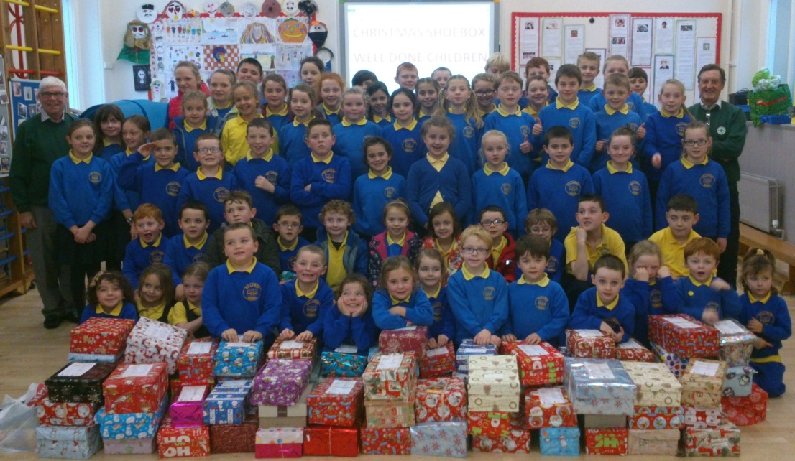

CHRISTMAS SHOEBOXES FOR BLYTHSWOOD CARE CHARITY

