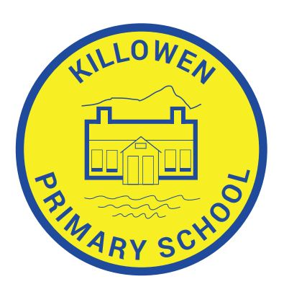
Killowen Primary School Acting Principal
88 Killowen Old Road Mrs. Órla Murphy
Rostrevor
Co. Down Tel (028) 41738426
BT34 3AE
Faith, Friendship & Understanding
info@killowen.rostrevor.ni.sch.uk

10th January 2024

Dear Parent,

The School Nursing Service would like to offer the Flu vaccine to any pupils who missed the vaccine in school recently. Please see the table below for details of your nearest clinic. Consent forms and information leaflets will be available at each session. Parent/Guardians do not have to book - just turn up with your child/children and they can be given the nasal flu vaccine.

Date | Date | Area | Venue | Time
Thurs | 11/01/2024 | Newry | John Mitchell Place Clinic | 2:30 – 4:30pm
Thurs | 11/01/2024 | Kilkeel | Kilkeel Primary Care Centre | 2:30 – 4:30pm
Mon | 15/01/2024 | Banbridge | Banbridge Health & Care Centre | 2:30 – 4:30pm
Wed | 17/01/2024 | Craigavon | Brownlow Health Centre | 2:30 – 4:30pm
Wed | 17/01/2024 | Armagh | OT Treatment Room, Villa 2, St Luke’s Hospital Site | 2:30 – 4:30pm
Thurs | 18/01/2024 | Newry | John Mitchell Place Clinic | 2:30 – 4:30pm
Thurs | 18/01/2024 | Kilkeel | Kilkeel Primary Care Centre | 2:30 – 4:30pm
Mon | 22/01/2024 | Banbridge | Banbridge Health & Care Centre | 2:30 – 4:30pm
Tues | 23/01/2024 | Craigavon | Portadown Health Centre | 2:30 – 4:30pm
Wed | 24/01/2024 | Armagh | OT Treatment Room, Villa 2, St Luke’s Hospital Site | 2:30 – 4:30pm

Yours sincerely,

M Murtagh
Principal (Acting)

