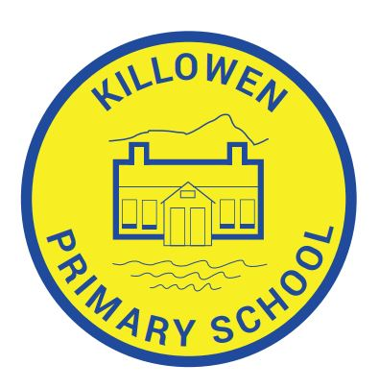

Did you receive an education at Killowen or did your child/children?

We are currently fundraising to replace our Maths Scheme and introduce new Literacy and Numeracy software packages into the school to enhance the teaching and learning experiences of our current pupils.

If you are thinking you’d like to help the current generation of Killowen PS pupils by generously donating towards our efforts, we would love to hear from you! Every little helps!

Mr. M. Murtagh (Principal, Acting)

mmurtagh697@c2kni.net

