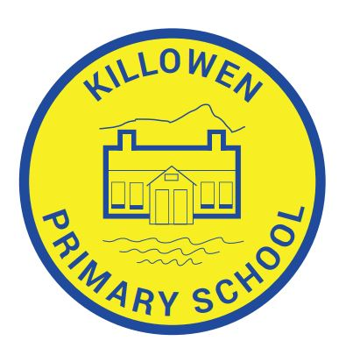
Killowen Primary School Acting Principal
88 Killowen Old Road Mrs. Órla Murphy
Rostrevor
Co. Down Tel (028) 41738426
BT34 3AE
Faith, Friendship & Understanding
info@killowen.rostrevor.ni.sch.uk

5th November 2021

Dear Parent,

Re: “Wear a Woolly Hat” in aid of Mourne Stimulus, Kilkeel

Please note that Friday 12th November 2021 will be “Wear your woolly hat to school” day. We would ask you to kindly forward £1.00 donation with your child and all donations received will be in aid of Mourne Stimulus, Kilkeel.

Thank you for your assistance in this matter.

Yours sincerely,

Órla Murphy

Mrs Órla Murphy
Acting Principal.

